Finding notes on the neck

The aim of this book is to help you fully understand the neck of the guitar. By following this book you will be able to find your way around the neck of your guitar with ease.
As the neck has so many notes it is important you are capable of working notes out and find them for yourself. Knowing your way around the neck and where all the notes are will improve your playing without exception. To memorise scales, chords even pieces, if you know the notes on the neck this will all be a lot easier to learn and memorise. The notes on the neck never move, they are the reference points to work from and the key to all your problems.

The Pitch of each note is named after the first 7 letters of the alphabet:
A B C D E F G
In-between these notes there are sharps (#) and flats (b).
1 | 2 | 3 | 4 | 5 | 6 | 7 | 8 | 9 | 10 | 11 | 12
A | A#/Bb | B | C | C#/Db | D | D#/Eb | E | F | F#/Gb | G | G#/Ab

A# and Bb is the same note. C#/Db is the same note. D#/Eb is the same note, F#/Gb is the same note and G#/Ab is the same.
If you go up from the note A in Semitones (up 1 fret at a time) all the notes will be
A A# B C C# D D# E F F# G G# A, by convention, as each note is ascending it will be sharpened.
If you go down from A in Semitones (down 1 fret at a time) all the notes will be
A Ab G Gb F E Eb D Db C B Bb A, by convention, as each note is descending it will be flattened.
Overall there are 12 notes.
The notes are always going to follow this pattern. For example:
If I start on the note D and go up in semitones (1 fret at a time) it will go
D D# E F F# G G# A A# B C C# D
If go down in semitones from D it will go
D Db C B Bb A Ab G Gb F E Eb D
The only rule to remember is B and E don’t have sharps (#) and C and F don’t have flats (b)
A A#/Bb B C C#/Db D D#/Eb E F F#/Gb G G#/Ab
Now try running through the following, going up all the notes and down.
ANSWERS ARE ON PAGE 12
I have started this one for you
B C C#
Going down
B Bb A
Going up
D
Going Down
D
Going up
C
Going Down
C
Going Up
E
Going Down
E
Going up
G
Going Down
G
Going Up
F
Going Down
F
Now try the same but starting on a sharp and flat
Going up
A#
Going Down
Bb

Going Up
C#
Going down
Db
Going up
D#
Going down
Eb
Going up
F#
Going down
Gb
Going up
G#
Going down
Ab

Now you know all the notes, let’s try and find them on a guitar.
Below is a diagram showing the notes of the open strings of your guitar
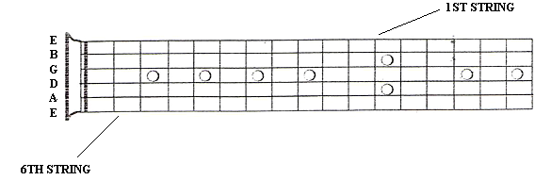
The open 6th string is the lowest E on your guitar and the open 1st string is you highest E on your guitar.
To find the notes on the guitar it is important that you know the open string tunings.
To work out the notes on your guitar, we are first going to start with the 6th string.
As in the exercises before it works the same way. We start with E then the next note going up from E will be F.
As that is a semitone up from E (1 fret) this means the first fret on the 6th string will be F.
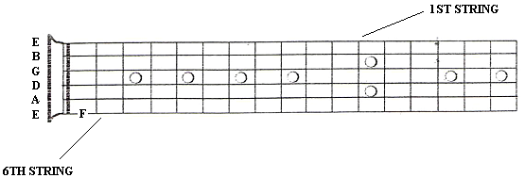
The next note up from F is F#. This means the 2nd fret on the 6th string will be F#.
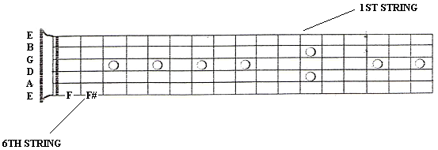
The next note from F# is G. This means the 3rd fret on the 6th string is G.
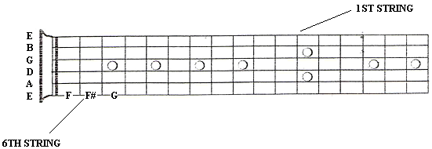
When working out where the notes are on the neck, always work from the open string. This way you can accurately work along the neck and will always know where you are!
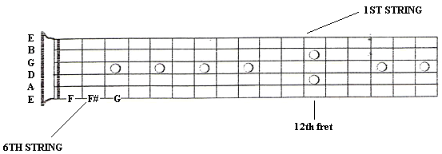 Now try and work out the rest of the notes on the 6th string up until the 12th fret.
ANSWERS ON THE PAGE 14
Using the same method, try and work out the notes on the 5th string. I have done the first 2 frets for you.
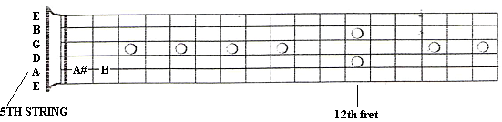
4th string
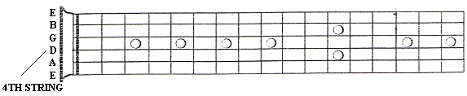
3rd string
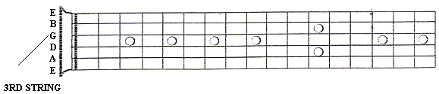

2nd string
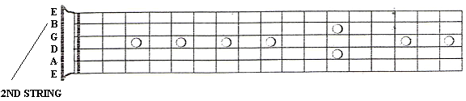
1st string
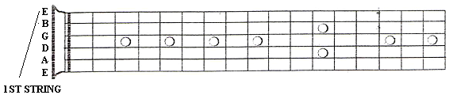
Also remember that F# is the same note as Gb, G# is the same as Ab etc. Try writing on the necks below the fret names as sharps (#) and flats (b). I’ve done the first 4 frets for you.
6th string
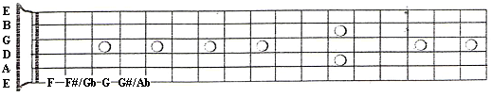
5th string
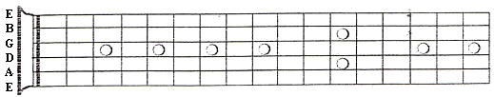
4th string

3rd string
2nd string
1st string
The reason I have asked you to work out the notes up until the 12th fret and no more is because the guitar repeats at the 12th fret. If you look at the notes we have worked out, you will notice that the 12th fret note has the same name as the open string note. Therefore the 13th fret will be the same as fret 1, and the 14th fret will be the same as fret 2 and so on. This is known as an octave.
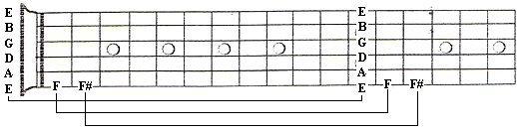

Octaves
An octave is a complete range of 12 notes. If you start at one note and then run up or down through every note one note at a time, you will have covered the range of one octave.
For example:
If you look at the guitar neck, on the 6th string we start with the open string E. Then we work through all of the other notes and finish on the 12th fret which is E. This is an octave higher than the E we originally started on.
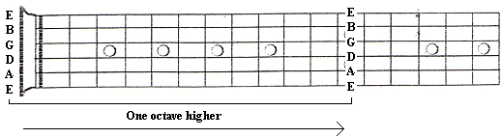
It also works the same going backwards. If we start on the E on the 12th fret, run backwards through all the other notes then finish with the open E string. This is an octave lower than we originally started on.
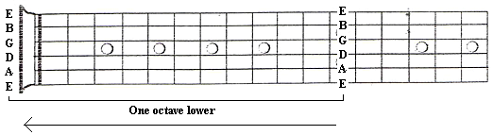
Within the first 12 frets of the guitar there are many octaves. To find all of the octaves on the guitar there is a simple pattern to follow. Follow the step by step guide on how to find you octaves. It is essential you know the notes on the 6th and 5th string to find the octaves.
This octave technique is another method to help you find notes quickly around the neck.

PLEASE TURN TO NEXT PAGE.

- From the root note, move 2 strings down and 2 frets across
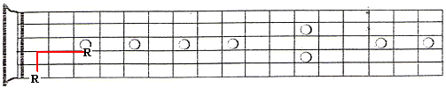
- Then to find the next octave on the B string, move 2 strings down and 3 frets across
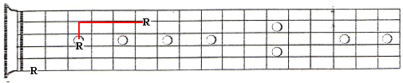
- From that octave, you now need to go the 5th string staying on the same fret and move across 2 frets.
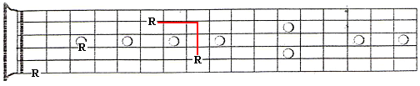
- Now repeat steps 1 and 2
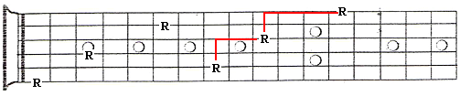
- Now you are on the first string, you stay on the same fret and go to the 6th string. 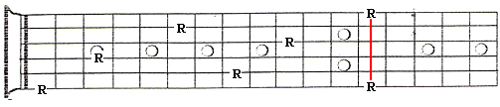

Now you can repeat the pattern all over again.
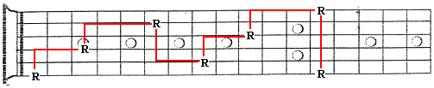
Starting on 5th string
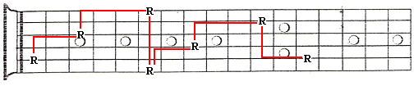

TRY DOING THIS WITH ALL THE NOTES ON THE NECK

ANSWERS
B C C# D D# E F F# G G# A A# B
Going down
B Bb A Ab G Gb F E Eb D Db C B
Going up
D D# E F F# G G# A A# B C C# D
Going Down
D Db C B Bb A Ab G Gb F E Eb D
Going up
C C# D D# E F F# G G# A A# B C
Going Down
C B Bb A Ab G Gb F E Eb D Db C
Going Up
E F F# G G# A A# B C C# D D# E
Going Down
E Eb D Db C B Bb A Ab G Gb F E
Going up
G G# A A# B C C# D D# E F F# G
Going Down
G Gb F E Eb D Db C B Bb A Ab G
Going Up
F F# G G# A A# B C C# D D# E F
Going Down
F E Eb D Db C B Bb A Ab G Gb F

Now try the same but starting on a sharp and flat
Going up
A# B C C# D D# E F F# G G# A A#
Going Down
Bb A Ab G Gb F E Eb D Db C B Bb
Going Up
C# D D# E F F# G G# A A# B C C#
Going down
Db C B Bb A Ab G Gb F E Eb D Db
Going up
D# E F F# G G# A A# B C C# D D#
Going down
Eb D Db C B Bb A Ab G Gb F E Eb
Going up
F# G G# A A# B C C# D D# E F F#
Going down
Gb F E Eb D Db C B Bb A Ab G Gb
Going up
G# A A# B C C# D D# E F F# G G#
Going down
Ab G Gb F E Eb D Db C B Bb A Ab

6th string notes
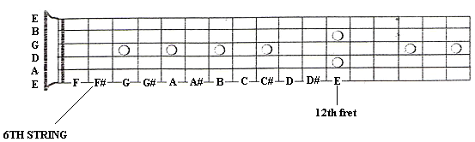
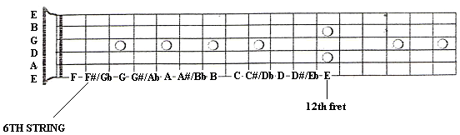
5th string notes
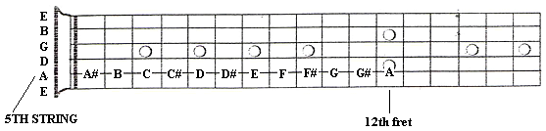
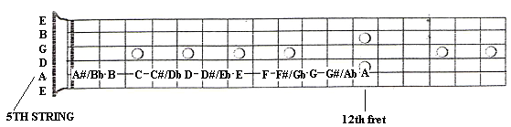

4th string notes
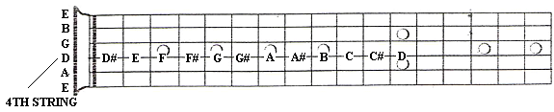
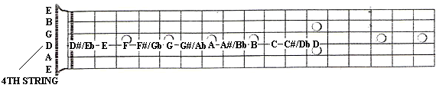
3rd string notes
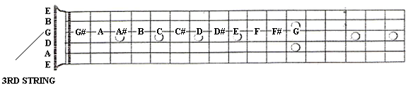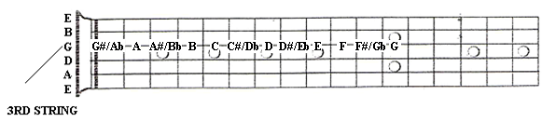
2nd string notes
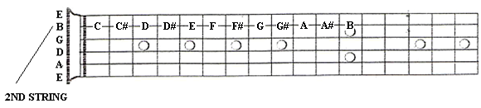
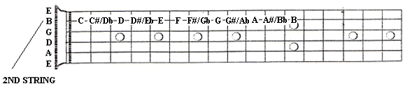
1st string notes
