Chord Sheets (Small Chords)
A
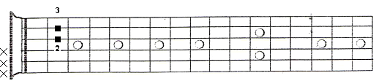
B
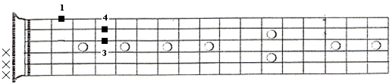
C
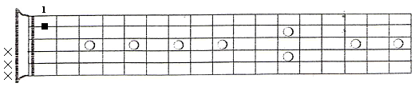
D
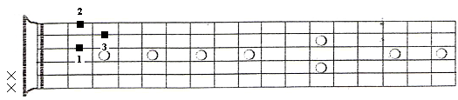
E
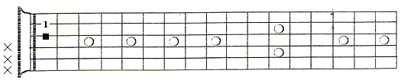

F
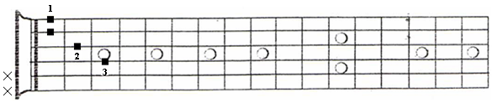
G
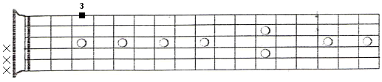
Am
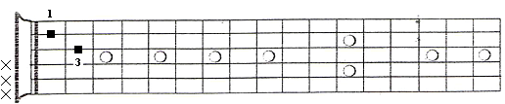
Bm
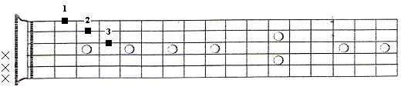
Cm
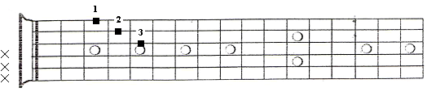

Dm
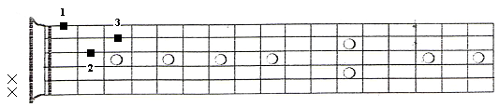
Em
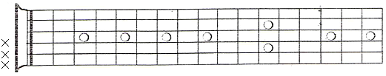
Fm
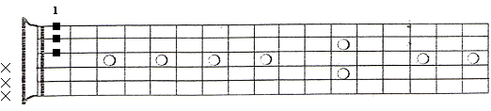
Gm
